**Lab06**

**NAME ________________________ NAME ________________________**

*This lab assignment should be done in teams of two. Go through the exercises below and show your results.*

The task for this lab is to insert a new image texture into an area of an existing image, such that it is projected correctly. For example, the image below shows a planar area that is covered with a sign for “ComEd”. Let’s say that we want to replace this sign with a sign for Mines Logo.

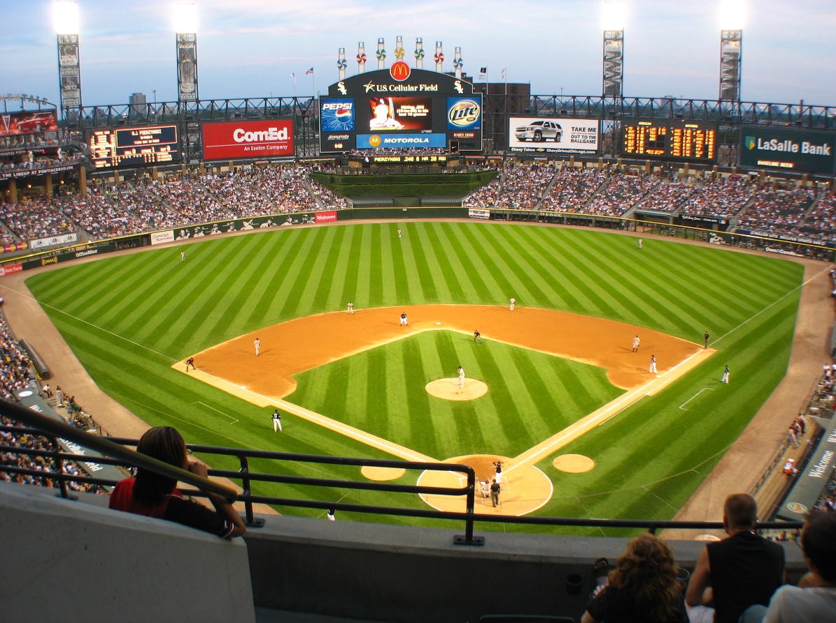

US Cellular field (image at <https://upload.wikimedia.org/wikipedia/commons/d/dd/US_Cellular.jpg>).



Mines Logo image (on course website).

Following the methods shown in class, map a new image texture onto a planar area of an existing image, using a projective transform (homography). You can use the US Cellular and Mines Logo images, or find your own.

**Hints**

* You will have to remove (i.e., set to zeros) the region that you want to replace in your input image.
* OpenCV has a useful function named “fillConvexPoly” that draws a filled convex polygon on an image.
* If you are using MATLAB, there are more hints in the tasks document available on Canvas.

**Turn in:**

* Upload the original image.
* Upload the image that has the replacement texture.
* Upload the combined image, where the planar area is replaced by the other texture.
* Upload your Python pr MATLAB program.